1. GROUP BY with WHERE - Orders by Year and Quarter

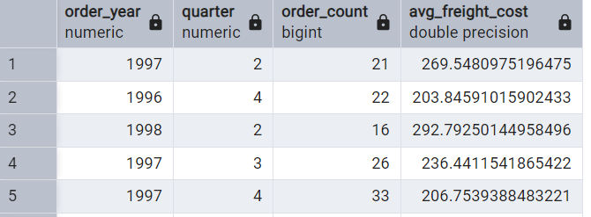

2.      GROUP BY with HAVING - High Volume Ship Regions

Display, ship region, no of orders in each region, min and max freight cost  
 Filter regions where no of orders >= 5

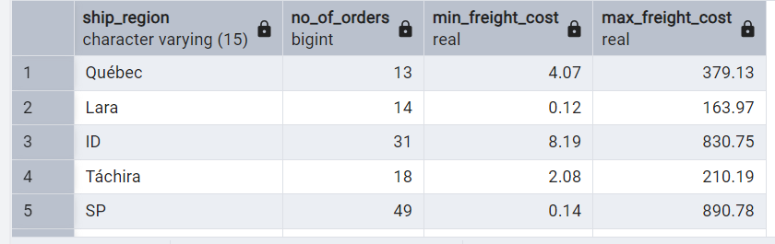

1. Get all title designations across employees and customers ( Try UNION & UNION ALL)

UNION UNION ALL

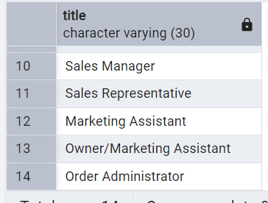 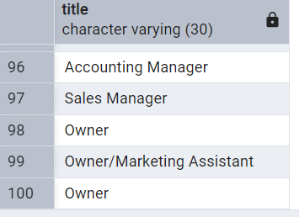

4.      Find categories that have both discontinued and in-stock products

(Display category_id, instock means units_in_stock > 0, Intersect)

5.      Find orders that have no discounted items (Display the  order_id, EXCEPT)

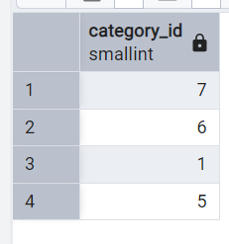  
5.      Find orders that have no discounted items (Display the  order_id, EXCEPT)

